File 44_region_base_year_dvmt.csv
May 29, 2026
Definition of the Input File

This optional file (see https://visioneval.github.io/docs/model-inputs.html) allows to adjust how heavy truck VMT and commercial service DVMT is grown, but the research team believes the following two items to be true based on experiments with this data set that are not clear from the documentation.
- First, this file is required—not optional. Failure to include this file caused VE to crash.
- Second, the file has two different names in the documentation: region_base_year_dvmt and region_base_year_hvytrk_dvmt.docx. The first name is the correct one.
That said, this input file does not need to be changed unless the user wants to adjust heavy truck DVMT. For example, suppose that the user notices that execution of the model for their region during the base year gives a heavy truck DVMT of 400,000. Suppose further that the user knows from previous experience that during the base year, the heavy truck DVMT is 700,000. In that case, cell C2 shown below would be changed from “NA” to “700,000”. (The values in cell B2 and D2, while logical, are not explained fully in the VisionEval documentation).
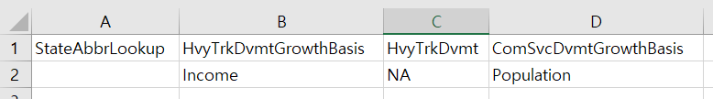
Possible Scenario
This file is not discussed in A Playbook for Simplified Approaches for Creating Scenarios in VisionEval which is not surprising. The same format as shown above, however, was used by Fresno (California’s) VisionEval exercise (see San Joaquin Valley VisionEval Model Documentation) except that in column C2, the authors used the heavy truck DVMT from the regional travel demand model (31.7 M).
The one reason the research team can think of for using this file is to help with model calibration. For regions that are new to VisionEval, there may be an interest in comparing VE outputs to traditional model outputs. By starting the a base year truck DVMT that derived from regional data, one can have greater confidence that other truck-related outputs in VisionEval may be specific to the region.
Method Used for Virginia
No modification to this file was performed, except to confirm that (1) the proper name is region_base_year_dvmt (changing the name caused VisionEval to crash) and (2) that placing a value in cell C2 instead of NA indeed changes the outputs (e.g., putting a number in cell C2, provided it is of course different from the input value provided by VisionEval for the base year, will yield a different DVMT in the forecast year, which can be obtained by summing the attributes HvyTrkUrbanDvmt and HvyTrkNonUrbanDvmt found within the output file named something like Region_CentralVirginia_2045 where “CentralVirginia” is the name the user has given to their VisionEval model.

